Content Overview

**The Best Places in Europe for Your Career**

We’re aiming to create a content marketing campaign that looks into which white/ blue-collar jobs offer a better lifestyle outside of the UK.

The interactive tool - will show users a data visualisation of which jobs offer a better or worse lifestyle outside of the UK. This will be based on a weighted index that looks into the average salary for each job title, as well as each country’s average disposable income, working hours and holiday/ annual leave days.

The static infographic – will show users each job title & where, based on our weighted index, do they offer a better lifestyle outside of the UK

The survey – will be used to find out how people would feel about uprooting their lives to move to a different country for more money. The survey results will also allow us to tie in with Brexit.

**Tool**

Tool Brief

We will gather a list of the UK’s 50 most popular jobs. We will then take this list and make sure that it is inclusive of only white & blue-collar jobs (e.g. doctor or train driver). We will then determine the average salary that you can expect to earn for each job title within the UK. We will take these job titles and determine the average salary in each European country. For both the UK and all European countries we will also research to average disposable income, average working hours & the average amount of holiday days workers receive.

Within the interactive tool, there will be no start or finish screen. A user will be immediately presented with the data (with the default view being the UK’s data for each job title). There will be two options for them to choose from:

1. Select Job Title

OR

1. Select Country

Depending on which the user chooses they will be displayed with one of the following:

1. A ranking list of the best country to work in for your specific job title (e.g. teacher). We will create a weighted index for the backend of the tool that will take into consideration salary, disposable income, working hours & holiday days to determine the best country for each job. We will do this by giving each variable a score, the higher the score for each variable, the better the country is to work in.

Example data (UK vs. France):

Job Title: Teacher

Salary: UK = £29,970 vs. France = £25,230

Disposable Income: UK = £25,700 vs. France = £22,742

Average Working Hours: UK = 43.6 vs. France = 35

Bank Holiday Days: UK = 8 vs. France = 11

Annual Leave: UK = 20 vs. France = 25

OR

1. A ranking list of the best jobs to do within the country based on the average salary you can expect to earn. Again we will create a weighted index for the backend of the tool.

Once the users are presented with the weighted index, they will then be able to use advanced filters to display results based on the variables. For example, say someone chose the country they wanted to live in, they would then be able to filter salary from high to low to see the best-paid jobs. They would also be able to choose a salary range to see which jobs would meet their expectations.

The following advanced filters would make sense for our two different options:

1. Choosing your job title = salary, working hours, holiday days

OR

1. Choose which country you would like to work in = salary

**Data Sources**

* <http://www.totaljobs.com/salary-checker/salary-calculator>
* <http://www.payscale.com/research/UK/Country=United_Kingdom/Salary>
* <http://www.tradingeconomics.com/united-kingdom/disposable-personal-income>
* <http://ec.europa.eu/eurostat>
* <https://www.theguardian.com/news/datablog/2011/dec/08/europe-working-hours>

**There are 2 stages of the Tool:**

1. Start screen – a user reads the instructions and presses ‘Discover’
2. Tool - List displaying either the best country to work in for your job title based on weighted index, or the best job title for the country you want to move to, based on salary. Users pick which option they would like to explore out of the two above (they can also switch between the two). They can then use the following advanced filters to explore the database in more depth:
3. Chose to explore job title = salary, working hours, holiday days

OR

1. Chose to explore country = just salary

**How the tool should work:**

1. A users reads the start screen instructions and clicks ‘Discover’
2. The user will then see the first instruction. Once they have read this, they will be able to click anyone on the screen to see the second instruction. They will then click anyway to be presented with the tool.
3. The screen should be set by default to ‘Other’ as a job title. This will show them the best country to work in based on the countries average general income, disposable income, annual leave, bank holidays and working hours. (Our weighted index has already worked this out)
4. The user will then be able to either select a job title, or a country.
5. If they select a job title, they will see the list of countries (in ranking order based on our weight index), of where you would be better off working. Using an IP switcher, the country that the user is from should highlight in yellow. If they are not from a country listed, nothing should be highlighted.
6. A user will then be able to filter their results by disposable income, annual leave, bank holidays and working hours. Similar to the commuter piece, the weighted index rankings should re-calculate based on the filters. A user should also be able to click the reset button to see the ranked list before they started playing with the filters.
7. If a user selects ‘Country’ they will simply see the list of jobs ranked in order from best to worst salary.
8. Within both the Job Title & Country results, users should also be able to use the arrows to change the ranking order to be either A-Z or Z-A for names, or lowest – highest or highest – lowest for numbers.

We will use the survey to determine how UK adults would feel about leaving Britain to live & work in another country, e.g.   
  
- Would you consider moving to a different country if it meant you’d earn more money?   
- What would stop you from moving to a different country?

**Look & Feel Mood Board**

* Should be a simplistic design to avoid the page looking too complex because of all of the data

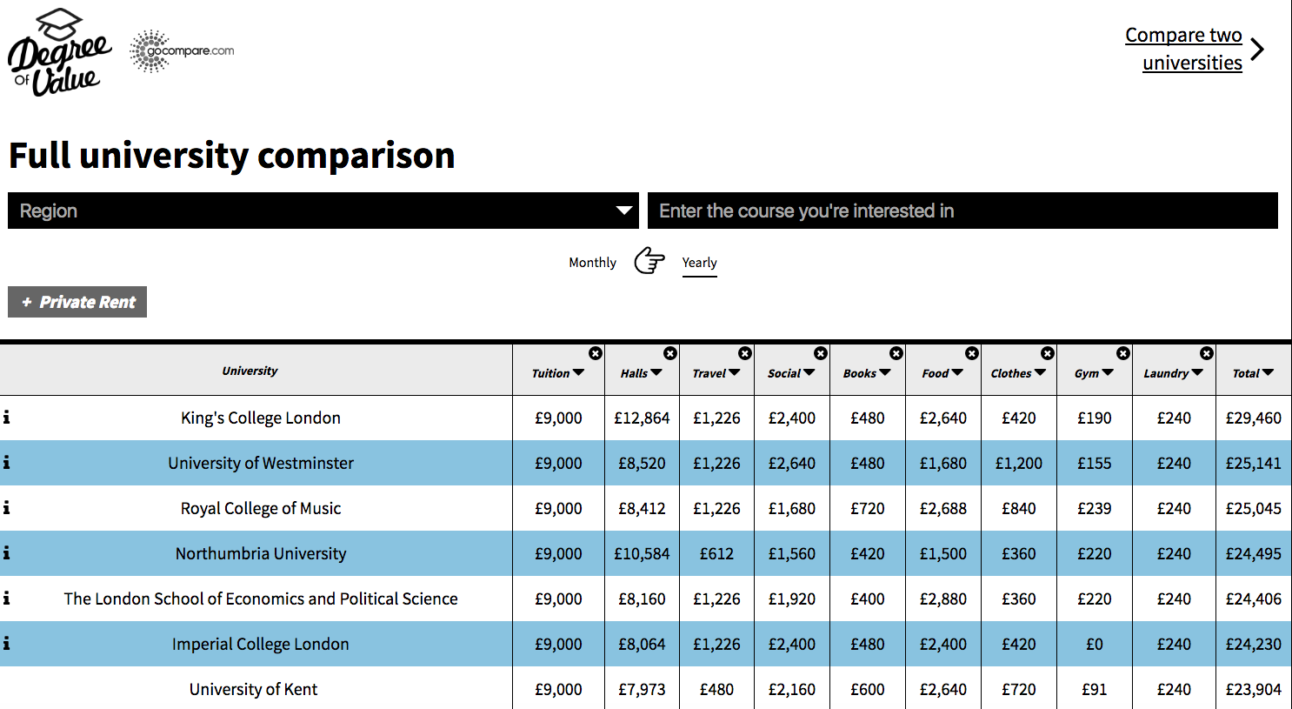

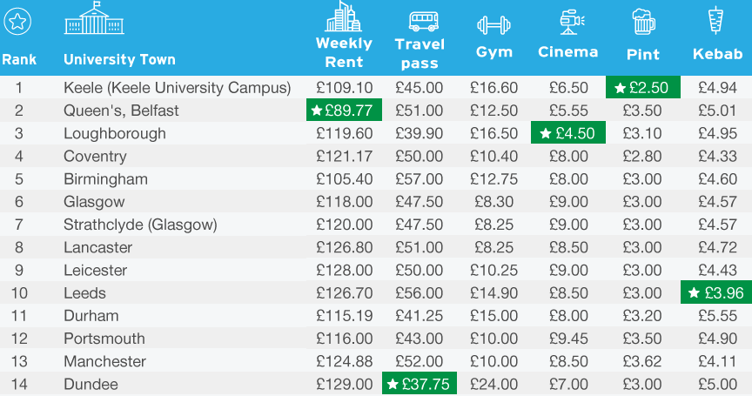

* Example sketch below:



**Quiz Technical Brief**

* There should be no start or finish screen
* Opening title
* Introduction text to explain the tool
* Social sharing buttons
* There will be a logo for the title
* Simplistic design
* There will be a section to display the various filters
* A ranking list to display results
* Embed code
* TotallyMoney Logo

**Other Technical Requirements**

* Responsive Design
* Include OpenGraph Tags for Facebook & Twitter Cards to share the results  
  A) Ensure any Tweets includes the @handle and statements   
  B) If users browser falls below 800px, a display:none; tag will be added onto the large AddThis Floating buttons
* Page Title & META Description
* Include Google Analytics code
* There will also need to be an area for an embed code to enhance sharability

**Static Brief**

* Should follow the same design as the tool
* Data table rather than panels
* List of each job and the best country to work in (based on our weighted index)
* Data sources, social share buttons, TotallyMoney.com logo and an embed code will be present at the bottom of the graphic/ microsite

**Survey Brief**

* The survey will be carried out using OnePoll
* We will ask 9 questions to 1000 UK Adults
* The survey will be used to determine how people would feel emotionally about moving to another country, i.e. what would motivate them, what would stop them.
* An example question: How much more would you have to earn in order for it to be worth moving to a different country.
* We will get a breakdown of the results based on location, age, gender & job title

**Press Hooks**

* The average Brit would have to earn £X more money to consider moving to a different country for work
* Where in the world could you earn more money & work fewer hours?
* The best European countries for Teachers to work in
* Those in Education could earn more money by moving to Germany

**Campaign Deliverables**

* Interactive Tool
* Static Infographic
* OnePoll Survey
* Press Release